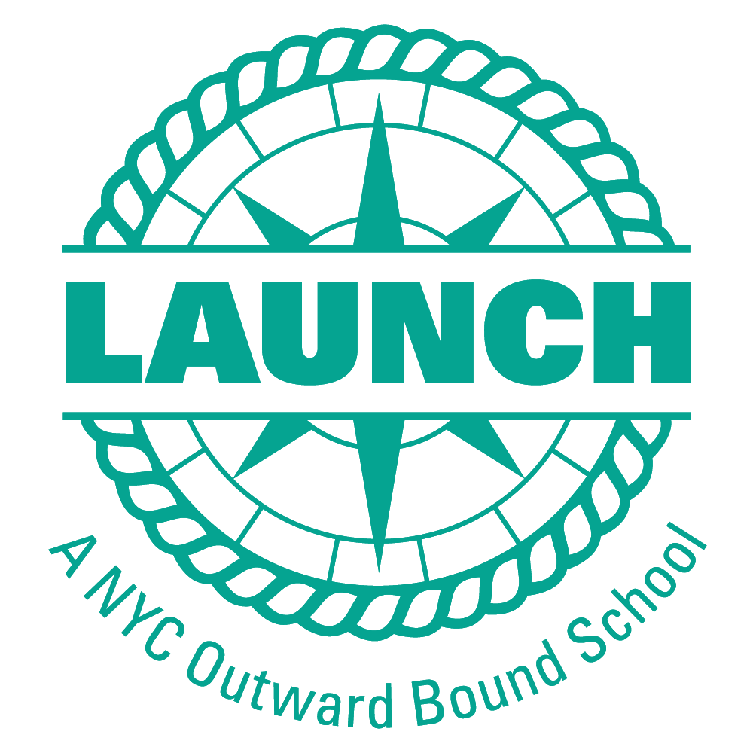 | SCHOOL UNIFORMS

What is the Launch uniform?
  - Black pants (shorts/skirts to the knee)
  - Maroon Launch polos (purchased through Launch)
  - Grey Launch Sweatshirt (purchased through Launch)
  - Any college sweatshirt or t-shirt can be worn any day of the week
  - We are in the process of designing an optional gym uniform which will be available soon.

Where can I purchase the Launch uniform?

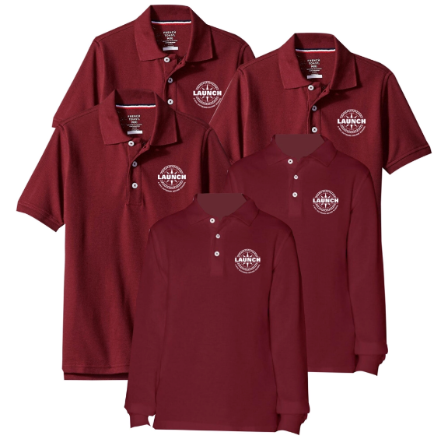 | Launch’s Uniform vendor is  THE LEAGUE BRAND  www.theleaguebrand.com/launch  Polos and sweatshirts are currently available. More products will be available soon.  IF YOU COMPLETE REGISTRATION BY  APRIL 15TH  you will receive a coupon for a free long-sleeve and short-sleeve polo.

When can I purchase the Launch uniform?

- Uniforms sales are available on the League Brand website.

- The League Brand will be present at New Family Night on Wednesday, May 22nd. You can purchase uniforms at the event and/or pick up your free uniform package if you use the coupon to indicate your child’s size on the website in advance.

